Assignment – 06

1. Create a heading (<h2>) with the text Hello World. Using JavaScript, change the text to
Welcome to DOM Manipulation when a button is clicked.
Code:
<html>
<head>
<title>Question 1</title>
<script>
function chngtxt() {
document.getElementById('heading').innerText = "Welcome to DOM Manipulation";
}
</script>
</head>
<body>
<h2 id="heading">Hello World</h2>
<button onclick="chngtxt()">Change Text</button>
</body>
</html>
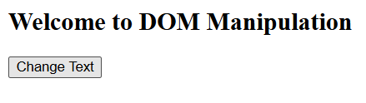
Output:
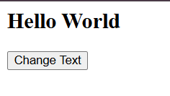
2. Write a paragraph of text and a button. When the button is clicked, toggle the visibility of the paragraph (show ? hide ? show). Change the button text accordingly.
Code:
<html>
<head>
<title>Question 2</title>
<script>
function togglevis() {
let p = document.getElementById('para');
let b = document.getElementById('btn');
if (p.style.display === "none") {
p.style.display = "block";
b.innerText = "Hide";
}
else {
p.style.display = "none";
b.innerText = "Show";
}
}
</script>
</head>
<body>
<p id="para">This is a Paragraph</p>
<button id = "btn" onclick="togglevis()">Hide</button>
</body>
</html>
Output:
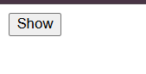
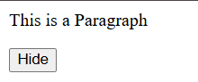
3. Create three buttons: Red, Green, Blue. When a button is clicked, change the background color of a <div> accordingly.Before changing the color, ask confirmation from the user if they really want to change the background color.
Code:
<html>
<head>
<title>Question 3</title>
<script>
function chng(color) {
if(confirm("Do you want to Change Colour ?")) {
document.getElementById('box').style.backgroundColor = color;
}
}
</script>
</head>
<body>
<div id="box" style="width: 600px; height: 300px; border: 2px solid black;" ></div>
<button onclick="chng('red')">Red</button>
<button onclick="chng('green')">Green</button>
<button onclick="chng('blue')">Blue</button>
</body>
</html>
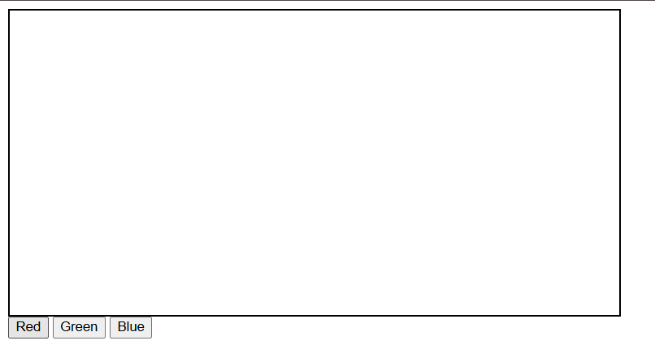
Output:
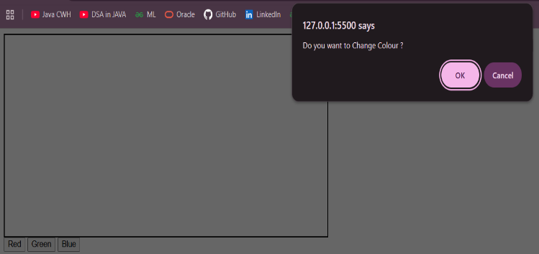
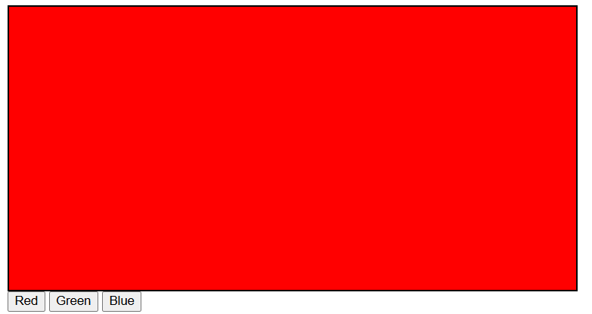

4. Create a simple counter with an input box and two buttons: + and - . + increases the value by 1, - decreases the value by 1 (not below 0).
Code:
<html>
<head>
<title>Question 4</title>
<script>
function cnt(val) {
let input = document.getElementById('inp');
let curr = parseInt(input.value);
if (curr + val >= 0) {
input.value = curr + val;
}
}
</script>
</head>
<body>
<input type="number" id="inp" value="0" readonly>
<button onclick="cnt(1)">+1</button>
<button onclick="cnt(-1)">-1</button>
</body>
</html>
Output:
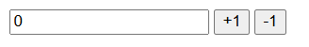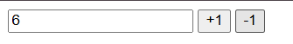
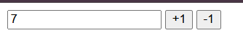

5. Design a form to take a number as input and, with the help of JS, check if the number is prime or not. Display the message in an alert box.
Code:
<html>
<head>
<title>Question 5</title>
<script>
function chknum() {
let n = parseInt(document.getElementById('inp').value);
if (n < 2) {
return alert("NOT PRIME");
}
for (let i = 2; i < n; i++) {
if (n % i === 0) {
return alert("NOT PRIME");
}
}
return alert("PRIME");
}
</script>
</head>
<body>
<input type="number" id="inp" placeholder="Enter a Number">
<button onclick="chknum()">Check</button>
</body>
</html>
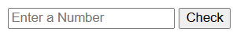
Output:
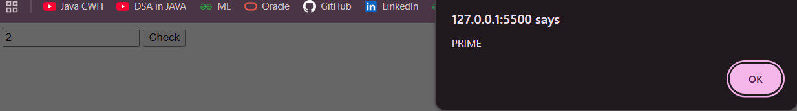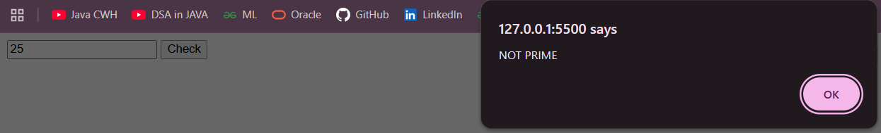
6. You are tasked with building a currency converter app that allows users to convert amounts between different currencies.The app should have dropdown menus for selecting the source and target currencies, an input field for entering the amount to be converted,and an output field for displaying the converted amount.The conversion rates to be used are as follows:
conversionRates = {
USD: { EUR: 0.93, GBP: 0.82, INR: 82.74, AUD: 1.47 },
EUR: { USD: 1.08, GBP: 0.88, INR: 89.06, AUD: 1.58 },
GBP: { USD: 1.22, EUR: 1.14, INR: 101.5, AUD: 1.80 },
INR: { USD: 0.012, EUR: 0.011, GBP: 0.0098, AUD: 0.018 },
AUD: { USD: 0.68, EUR: 0.63, GBP: 0.55, INR: 55.87 }
};
The app should display an error message if any of the fields are empty or if the "From" and "To" currencies are the same.
Code:
<html>

<head>
<meta charset="UTF-8">
<title>Currency Converter</title>
<style>
body {
font-family: Arial, sans-serif;
background: #f2f2f2;
display: flex;
justify-content: center;
align-items: center;
height: 100vh;
}
.container {
background: white;
padding: 30px;
width: 320px;
border-radius: 10px;
box-shadow: 0 0 10px rgba(0, 0, 0, 0.2);
}
h2 {
text-align: center;
margin-bottom: 20px;
}
label {
font-weight: bold;
}
select,
input {
width: 100%;
padding: 10px;
margin-top: 5px;
margin-bottom: 15px;
border-radius: 5px;
border: 1px solid #ccc;
font-size: 15px;
}
button {
width: 100%;
padding: 12px;
background: black;
color: white;
border: none;
border-radius: 5px;
font-size: 16px;
cursor: pointer;
}
button:hover {
background: #333;
}
#error {
color: red;
text-align: center;
margin-bottom: 10px;
}
</style>
</head>
<body>
<div class="container">
<h2>Currency Converter</h2>
<div id="error"></div>
<label>From:</label>
<select id="fromCurrency">
<option value="">Select</option>
<option>USD</option>
<option>EUR</option>
<option>GBP</option>
<option>INR</option>
<option>AUD</option>
</select>
<input type="number" id="amount" placeholder="Enter amount">
<label>To:</label>
<select id="toCurrency">
<option value="">Select</option>
<option>USD</option>
<option>EUR</option>
<option>GBP</option>
<option>INR</option>
<option>AUD</option>
</select>
<input type="text" id="result" placeholder="Converted amount" readonly>
<button onclick="convertCurrency()">Convert</button>
</div>
<script>
const conversionRates = {
USD: { EUR: 0.93, GBP: 0.82, INR: 82.74, AUD: 1.47 },
EUR: { USD: 1.08, GBP: 0.88, INR: 89.06, AUD: 1.58 },
GBP: { USD: 1.22, EUR: 1.14, INR: 101.5, AUD: 1.80 },
INR: { USD: 0.012, EUR: 0.011, GBP: 0.0098, AUD: 0.018 },
AUD: { USD: 0.68, EUR: 0.63, GBP: 0.55, INR: 55.87 }
};
function convertCurrency() {
let from = document.getElementById("fromCurrency").value;
let to = document.getElementById("toCurrency").value;
let amount = document.getElementById("amount").value;
let result = document.getElementById("result");
let error = document.getElementById("error");
error.innerText = "";
if (from == "" || to == "" || amount == "") {
error.innerText = "Please fill all fields.";
result.value = "";
return;
}
if (from === to) {
error.innerText = "From and To currencies cannot be the same.";
result.value = "";
return;
}
let rate = conversionRates[from][to];
let converted = amount * rate;
result.value = converted.toFixed(2);
}
</script>
</body>
</html>
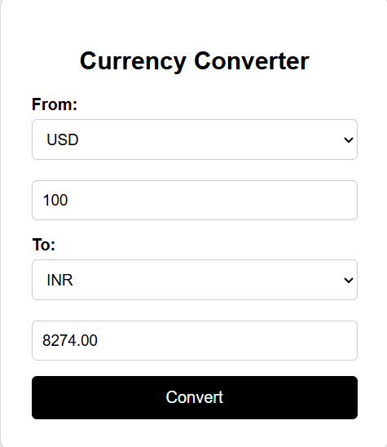
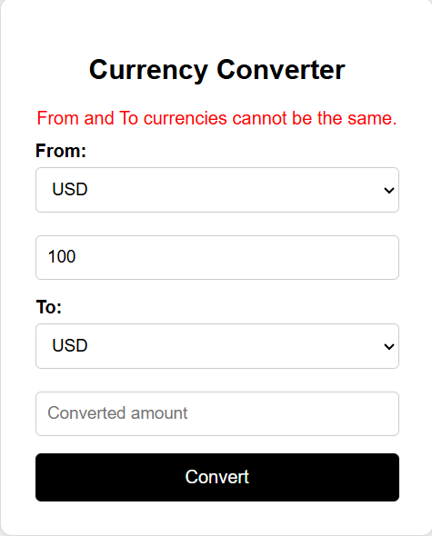
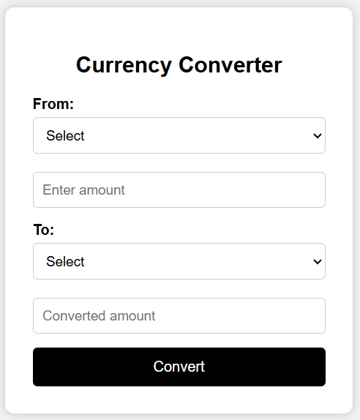
Output:
7. Create a registration form with fields for Name, Gender (radio button), Mobile, Address (textarea), Country (dropdown), Email, and Password. Use external JS to apply form validation to check:
a. None of the fields should be empty.
b. Mobile number should be a 10-digit valid mobile number.
c. Email should have a valid format.
d. Length of the password must be between 6-15.
Code:
Q7.html
<html>
<head>
<title>Registration Form</title>
<style>
body {
font-family: Arial;
background: #f2f2f2;
}
.container {
width: 400px;
margin: auto;
background: white;
padding: 20px;
border-radius: 8px;
box-shadow: 0 0 10px gray;
}
h2 {
text-align: center;
}
input,
select,
textarea {
width: 100%;
padding: 8px;
margin: 8px 0;
}
button {
width: 100%;
padding: 10px;
background: black;
color: white;
border: none;
font-size: 16px;
}
.gender {
display: flex;
gap: 20px;
margin: 10px 0;
}
</style>
</head>

<body>
<div class="container">
<h2>Registration Form</h2>
<form onsubmit="return validateForm()">
<label>Name</label>
<input type="text" id="name">
<label>Gender</label>
<div class="gender">
<label><input type="radio" name="gender" value="Male"> Male</label>
<label><input type="radio" name="gender" value="Female"> Female</label>
</div>
<br><br>
<label>Mobile</label>
<input type="text" id="mobile">
<label>Address</label>
<textarea id="address"></textarea>
<label>Country</label>
<select id="country">
<option value="">Select Country</option>
<option>India</option>
<option>USA</option>
<option>UK</option>
<option>Australia</option>
<option>UAE</option>
<option>Canada</option>
<option>South Africa</option>
</select>
<label>Email</label>
<input type="text" id="email">
<label>Password</label>
<input type="password" id="password">
<button type="submit">Register</button>
</form>
</div>
<script src="Q7.js"></script>
</body>

</html>
Q7.js
function validateForm() {

let name = document.getElementById("name").value;
let mobile = document.getElementById("mobile").value;
let address = document.getElementById("address").value;
let country = document.getElementById("country").value;
let email = document.getElementById("email").value;
let password = document.getElementById("password").value;
let gender = document.querySelector('input[name="gender"]:checked');

let mobilePattern = /^[0-9]{10}$/;
let emailPattern = /^[^ ]+@[^ ]+\.[a-z]{2,3}$/;
if (name == "" || mobile == "" || address == "" || country == "" || email == "" || password == "") {
alert("All fields must be filled");
return false;
}
if (!gender) {
alert("Please select gender");
return false;
}
if (!mobile.match(mobilePattern)) {
alert("Mobile number must be 10 digits");
return false;
}
if (!email.match(emailPattern)) {
alert("Enter a valid email");
return false;
}
if (password.length < 6 || password.length > 15) {
alert("Password must be between 6 and 15 characters");
return false;
}
alert("Registration Successful!");
return true;
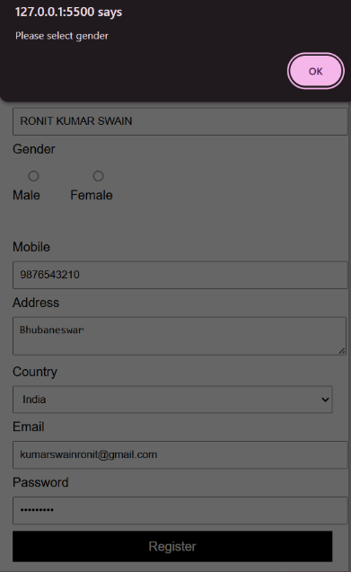
}
Output:
